Assignment -2

Name-Bhavye Sharma

Rollno-171473

Batch-IT-71

Hacker Rank ID-<https://www.hackerrank.com/h171473?hr_r=1>

Git HUB Repositry-<https://github.com/171473/Advanced-Software-System-Lab>

Q1. Say Hello, World! With Python.

Ans1.

print "Hello, World!"

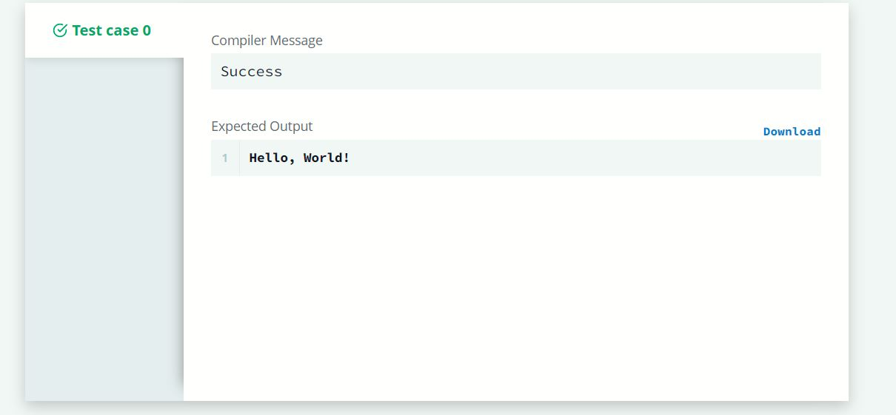

Q2. Python If-Else

Ans2. Code-

if n % 2 == 1:

print("Weird")

elif n % 2 == 0 and 2 <= n <= 5:

print("Not Weird")

elif n % 2 == 0 and 6 <= n <= 20:

print("Weird")

else:

print("Not Weird")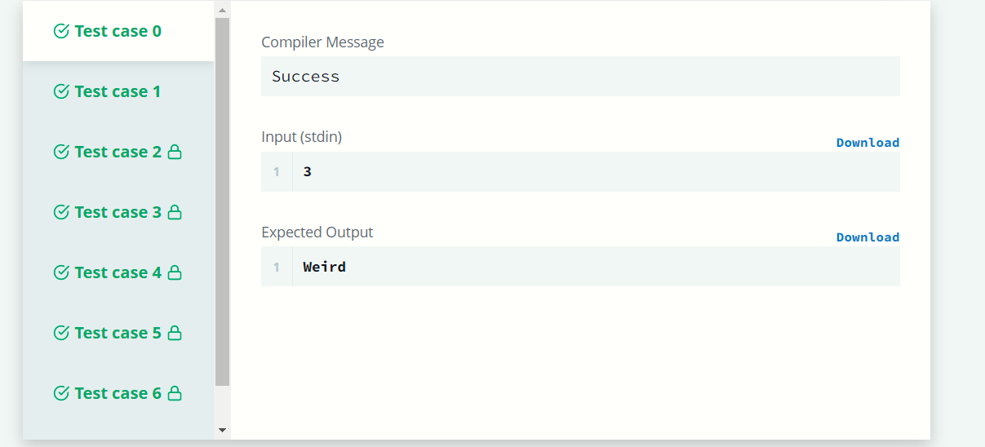

Q3. Arithmetic Operators

Ans3.

Code- a = int(input())

b = int(input())

print(a + b)

print(a - b)

print(a * b)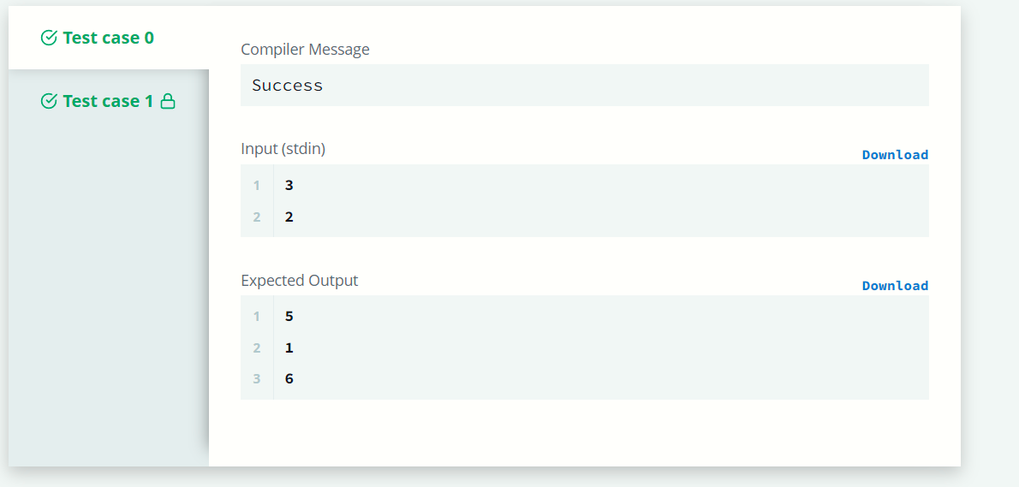

Q4. Python: Division

Ans4.

Code- a = int(input())

b = int(input())

print(a // b)

print(a / b)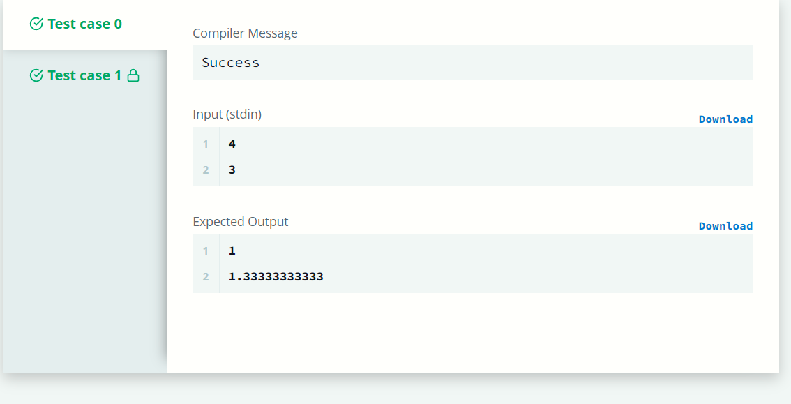

Q5. Loops

Ans5.

Code- if __name__ == '__main__':

n = int(input())

for i in range(n):

if i < n:

print(i**2)

